Setting up new clients for edit2021

# Create Local Client Directories

On xampp/htdoc

client_app -- copy all except content from another client & then modify

client_prototype – copy all except content from another client & then modify

# Create Local Database

Copy another client

Erase Content and Members (keep reference databases)

# Create Remote Database

# Create Remote Directories

Client – needs SSL

Client.edit -- – copy all except content from another client & then modify

Clien.prototype – needs SSL; – copy all except content from another client & then modify

# VueJS Environmental Variables

Set up both local and remote variables

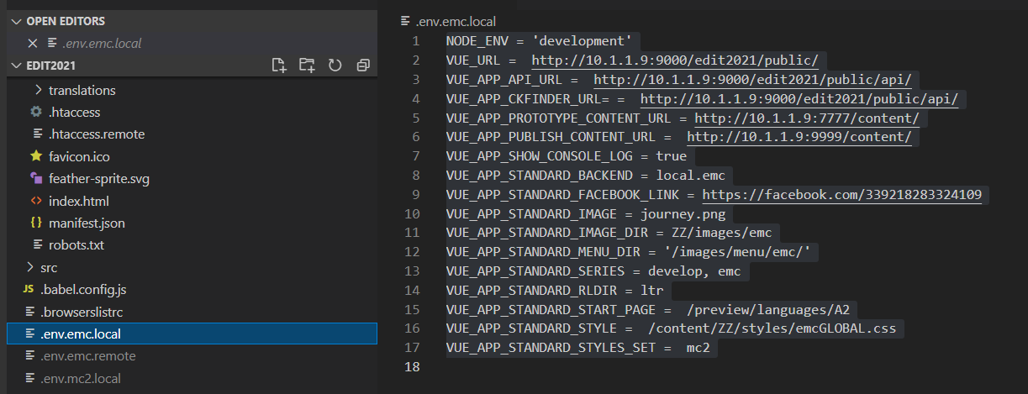

# API Environmental Variables

Set both local and remote .env files

Also make directories for php files unique to this client

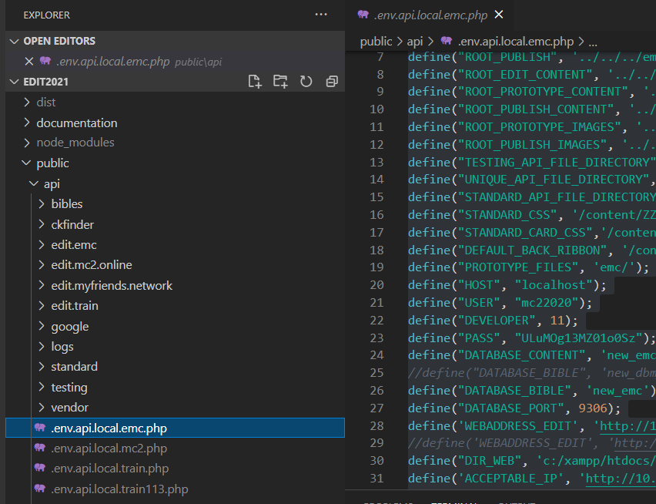

# CKEDITOR

Make any changes to the styles here.

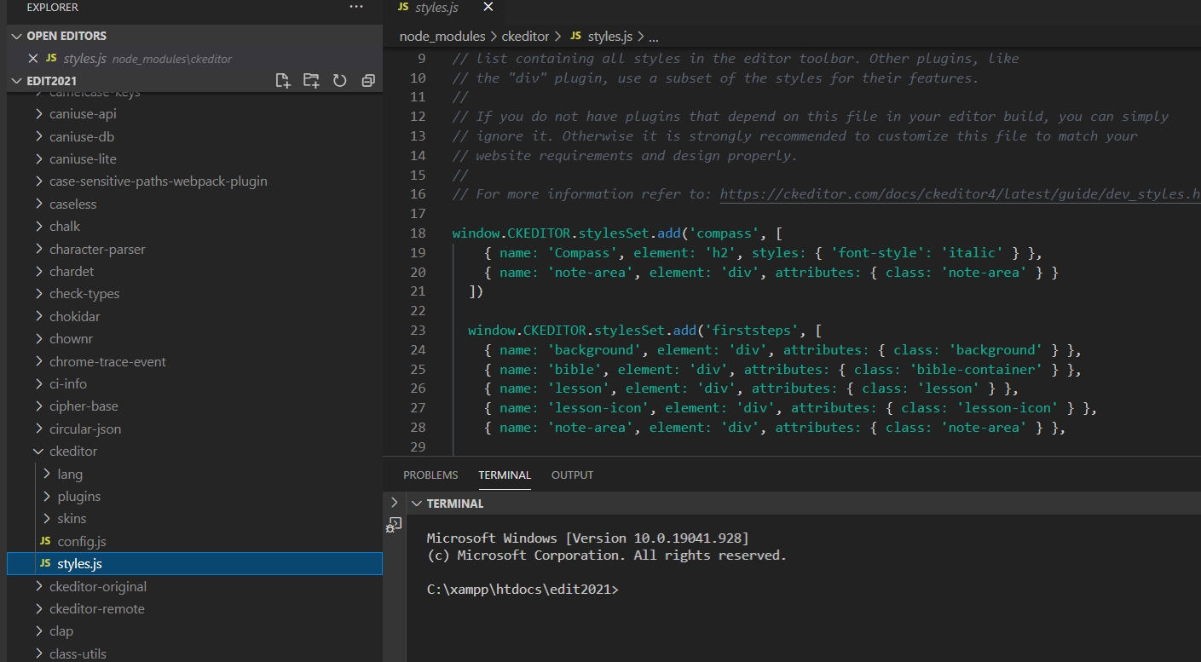

# CKFINDER

Set content/files and content/images

You will need to adjust the settings in this file

Also make sure you set :

'authentication' => function () {

return true;

},

I usually put this in the api/ckfinder/ahsan/ckfinder folder

www.persue-edit.sent67.com/api/ckfinder/ahsan/ckfinder/core/connector/php/vendor/cksource/ckfinder/src/CKSource/CKFinder/Config.php

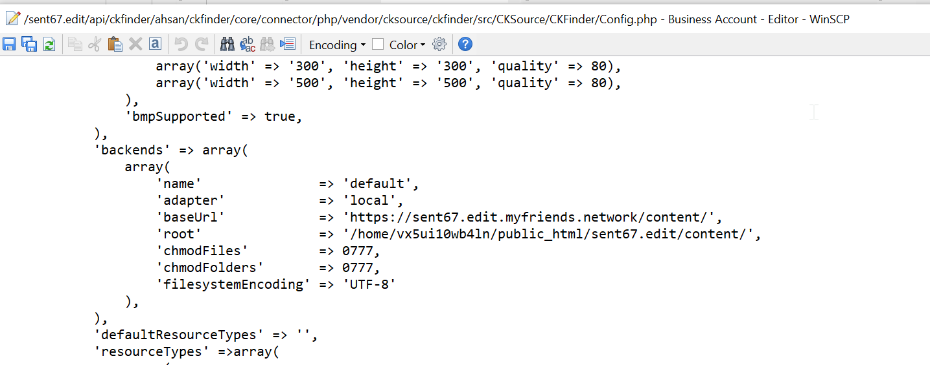

## .htaccess

Find an existing one and modify

# ckEditStyleSets

consider adding a new Style Set and Templates

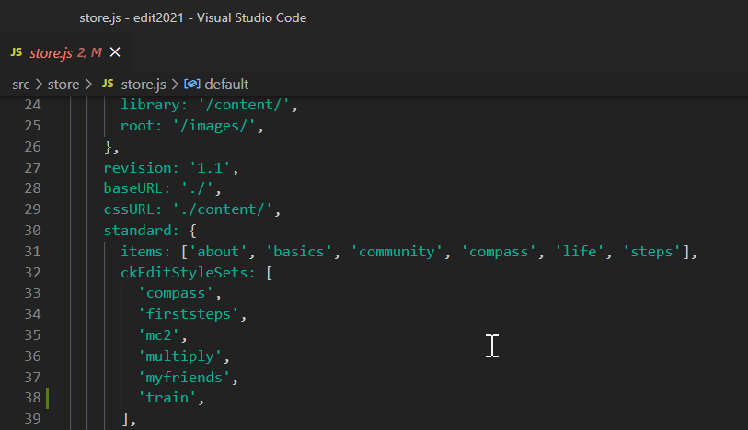

It is easier to create an html file and then change it to js using the following substitutions:

< replaced by \x3c

= replaced by \x3d

> replaced by \x3e

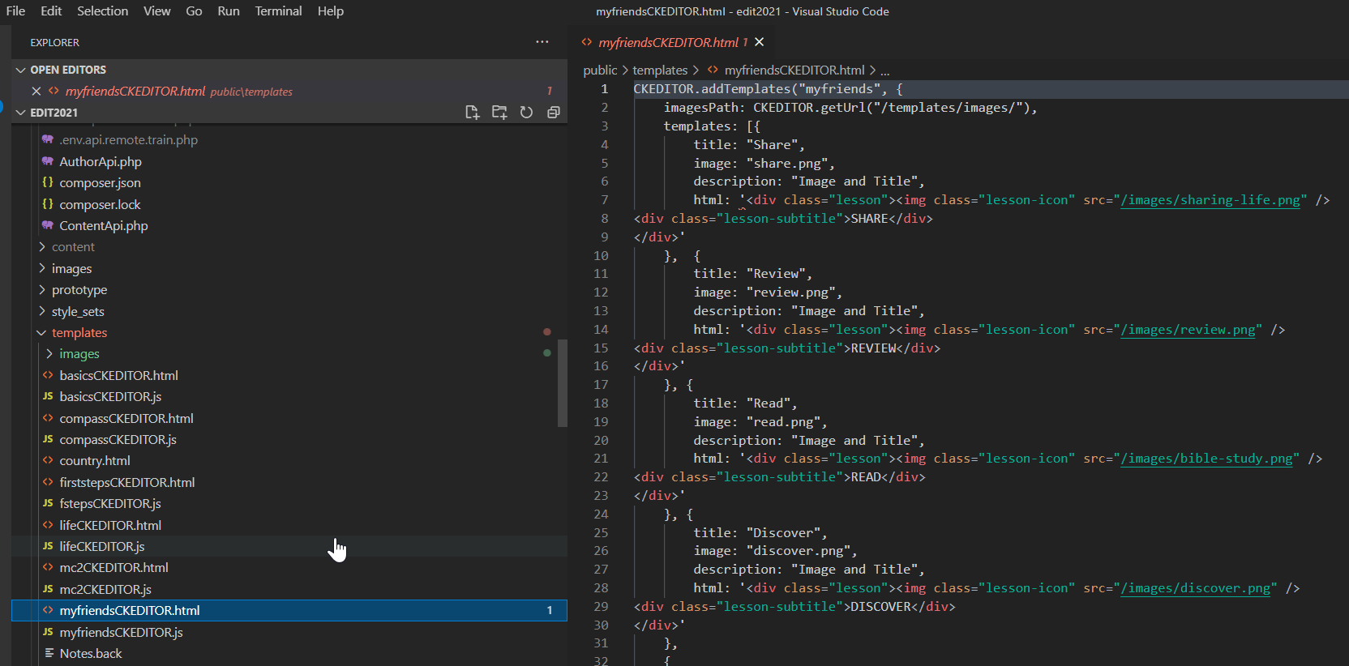

# Create .env files

# Update package.json

